What is XP?

"Extreme Programming is a discipline of software development based on values of simplicity, communication, feedback, and courage. It works by bringing the whole team together in the presence of simple practices, with enough feedback to enable the team to see where they are and to tune the practices to their unique situation."
Ron Jeffries, http://xprogramming.com/xpmag/whatisXP.htm
Extreme Programming (XP) has been called a "methodology", an "approach", and a "paradigm". None of these terms get to the point as well as saying that, for business people, XP
- is a predictable way to develop durable and adaptable software
- that your customers will love
- at maximum speed
- with minimal risk in the short term and the long term
So what's so extreme?
The name "eXtreme Programming" was coined by Kent Beck as a way to describe taking industry best practices of software development, and turning the knobs up to ten. For example,
- if customer involvement is a significant contributor to success, have them involved all the time;
- if incremental development is a significant contributor to success, make development iterations as short as possible (1-3 weeks) and production releases as frequent as possible;
- if testing early in the development cycle is a significant contributor to success, write tests before you write code;
- if software inspection is a significant contributor to success, have at least two sets of eyes on all production code;
- if regular software builds is a significant contributor to success, integrate all working code continuously;
- if the application of good design practices are a significant contributor to success, refactor the code whenever it slips away from good design practice;
- ... you get the picture.
XP is born out of the desire to apply best software practices in a disciplined, reproducible way. Its practioners develop good habits that produce consistently good results. And it does so in a way that encourages good communication so the business people don't promise the unachievable, and technical people don't achieve the unwarranted.
Here's one picture of how some of these practices work together:
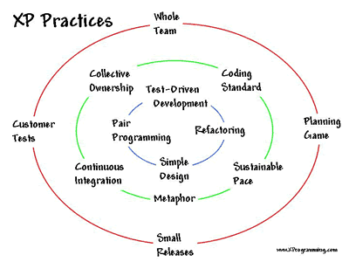 |  | The outer circle of practices keep the business and technical people in sync.  The inner circle of practices apply a discipline to individual developers to keep them focused on quality while they are in programming bliss.  The middle circle of practices makes sure the daily work of the individual programmers come together to meet the regular needs and interests of the business.
Although the word "Extreme" is in the name of the process, it actually balances out the two typical extremes of software development:
- code and fix - this is used all too often when people let their desire to get something going overrule their common sense and end up with shoddy work that is difficult or impossible to evolve;
- big up front design - this is used all too often when people let their desire to avoid shoddy work overrule their common sense and end up with an expensive and time-consuming paper solution that can't be verified until it's coded and relies on the false assumption that you can predict the future. These projects all too often end up in code and fix mode because paper design documents that are out of date don't keep people from writing poor code.
XP enables you to get reliable, working software quickly and continue development at a rapid, confident, and predictable pace with ever-increasing quality. One of the major contributors to the ever-increasing quality is the habit of including automated tests that are run all the time, so old bugs don't slip back in. These tests also give the developers confidence to make bold design changes when they seem warranted without having to have weeks of meetings trying to figure out the potential impacts of making a change. The tests give the business people a real handle on what is working in the system and what is not. So many of the other practices of XP reduce bureaucracy and increase effective communication in an environment where problems are either prevented in the first place or have no place to hide.
For the next level of detail, read XP Distilled by Roy Miller. For more detail, start with our Best of XP page.

